**EXP NO 1: CREATE A SIMPLE CLOUD SOFTWARE APPLICATION AND PROVIDE IT AS A SERVICE USING ANY CLOUD SERVICE PROVIDER TO DEMONSTRATE SOFTWARE AS A SERVICE (SAAS).**

**DATE:**

**AIM:**

**PROCEDURE:**

**STEP1: GOTO ZOHO.COM**

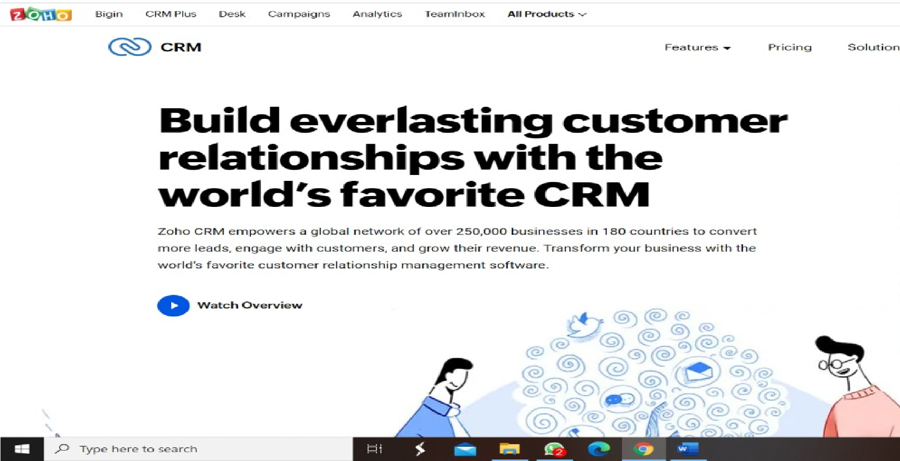

**STEP 2: LOGINTOTHE ZOHO.COM**



**STEP 3: SELECT ONE APPLICATION**

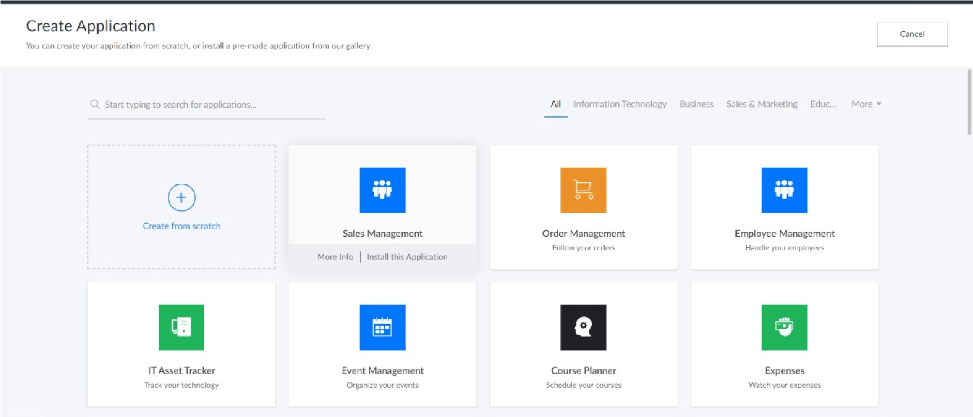

**STEP 4: ENTER APPLICATION NAME**

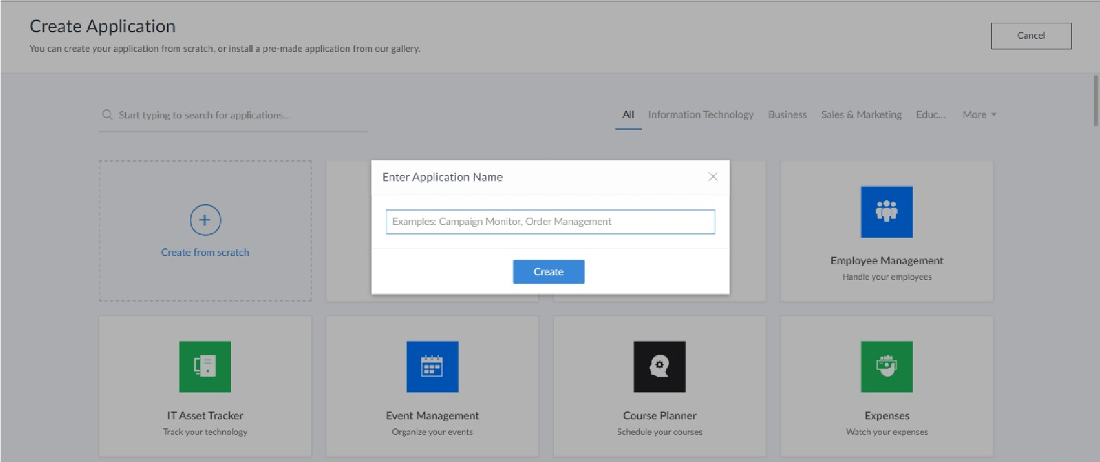

**STEP 5: CREATED NEW APPLICATION**

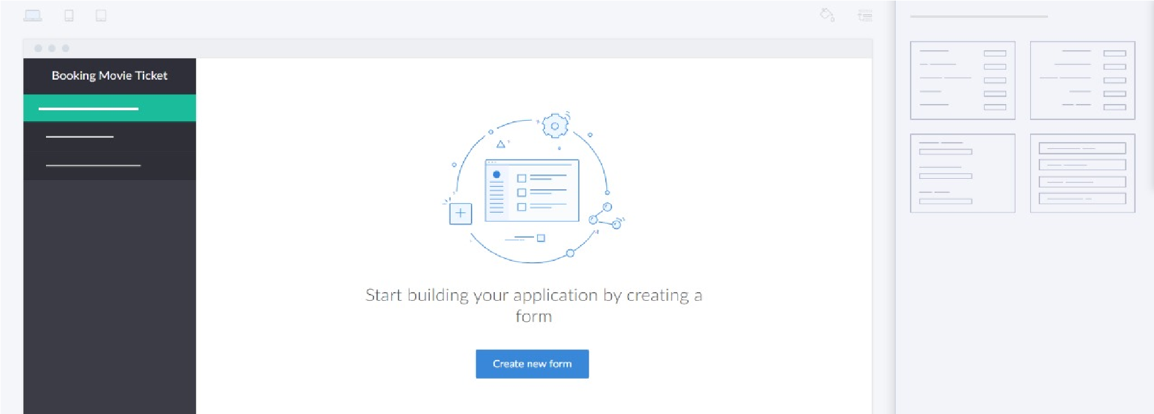

**STEP 6: SELECT ONE FORM**

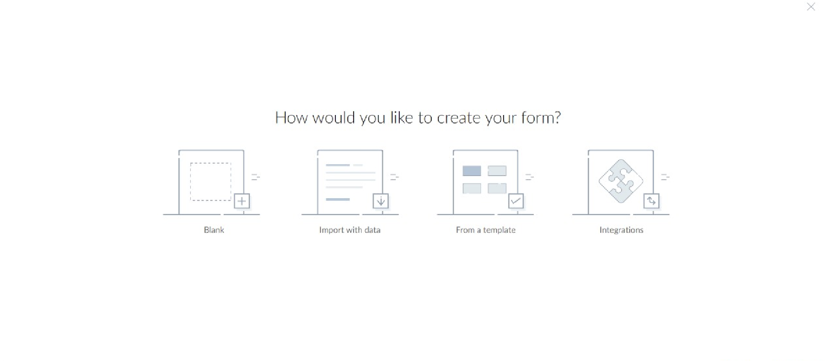**STEP 7: THE SOFTWARE HASE BEEN CREATED.**

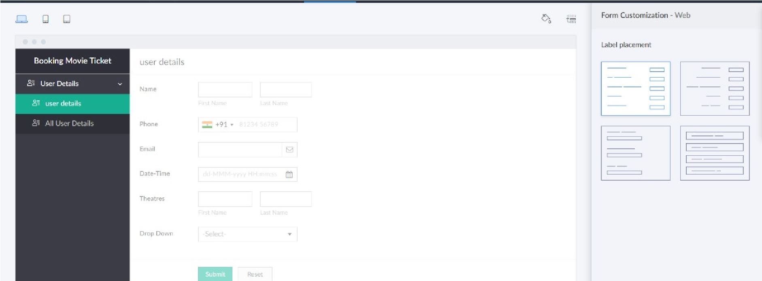

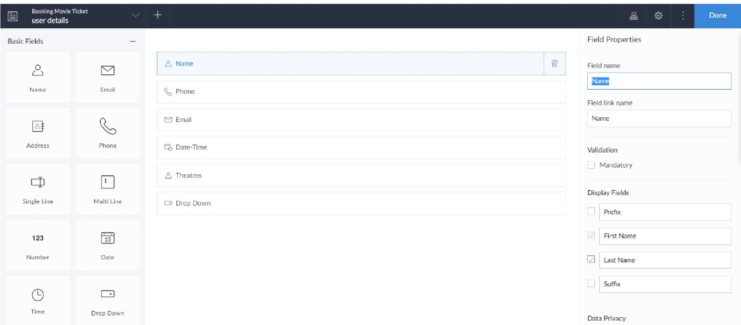**RESULT:**